

**UNIVERSIDAD TÉCNICA DE MACHALA**

Maestría en Software

**Asignatura:**  
Titulación II  
  
  
**Tema:**

**Taller N° 2: Análisis de la Literatura Línea-base**

**Docente:**

Walter Fuertes Díaz, PhD

**Estudiante:**

Ing. Jimmy Fernando Castillo Crespín

2021-2022

**Marco teórico**

|  |  |  |
| --- | --- | --- |
| **Conceptos** | **Razones para selección** | **Contribuciones para el estudio** |
|  | Google Cloud Platform es un conjunto de servicios e infraestructura que se pueden aplicar a muchos procesos empresariales [1]. | Gracias a todas las herramientas ofrecidas por Google Cloud Platform se puede diseñar arquitecturas de software más seguras y escalables y fáciles de testear y deployar [2]. |
|  | Son un conjunto de pequeños servicios granulares que son integrados a través de API Restful permitiendo el desarrollo y despliegue de aplicaciones de software [3]. | Permite crear una arquitectura con servicios distribuidos funcionando independientemente sin la necesidad de estar en un mismo sitio, aumentando el rendimiento, escalabilidad y seguridad de las aplicaciones [4]. |
|  | Express es el framework más popular y utilizado para aplicaciones backend con nodejs y creación de APIs [5]. | Permite la creación de endspoints restful robustas y seguras para ser utilizado en aplicaciones de software. |
|  | Es una interfaz de programación que permite la interacción con los servicios web de RESTful [6]. | Se implementa en conjunto con los microservicios y servirán para el intercambio de información entre clientes. |
|  | Iota es un DLT de código abierto que nació para solucionar los múltiples inconvenientes del blockchain como son problemas de rendimiento, medio ambiente y alto costos en comisiones [7]. | Con IOTA no existe la dependencia de mineros, alta escalabilidad, cero costos en comisiones y descentralización. Estos aspectos son convenientes para ser utilizados en aplicaciones Fintech [8]. |
|  | IoTex es una infraestructura de blockchain cuya principal característica es su protocolo de consenso en tiempo real llamado Roll-DPoS [9] la cual le permite una comunicación rápida y eficaz entre la blockchain y los millones de dispositivos conectados debido a que este protocolo utiliza un sistema de votación de minería de entre 21 a 50 delegados dentro de la blockchain y a su vez cada blockchain interactúa con diferentes dispositivos [10]. | Gracias a este protocolo se obtiene una red con un rendimiento significativamente más alta y el costo por cada transacción es mucho menor en comparación a otras blockchain [11], haciéndola perfecta para ser utilizado para smart contracts por su rapidez y bajo costo en comisiones. |
|  | Solidity es un lenguaje de programación considerada de alto nivel que hizo posible la creación de las Dapps [12]. | Lenguaje mayormente utilizado para la programación de los smart contracts que generalmente se las utiliza con el EVM de Ethereum. |
|  | Es una plataforma opensource para simplificar el desarrollo de aplicaciones DLT soportando más de 40 protocolos de blockchain y activos digitales en una misma API [13]. | Brinda beneficios como facilidad de utilizar sus apis, prueba del futuro y escalabilidad en el desarrollo de aplicaciones [14]. |
|  | Librería open-source utilizado para proteger cualquier secreto digital de posibles hackers, como contraseñas, privates key etc [15]. | Aumentaría la seguridad al momento de trabajar con contraseñas, llaves privadas o información sensible generadas en transacciones financieras. |
|  | Marco de arquitectura encargado de garantizar la seguridad de extremo a extremo en aplicaciones distribuidas [16]. | Es utilizada para implementar una red segura [17]. |
|  | Las aplicaciones Fintech gestionan información tanto personal como financiera de los usuarios, por tal motivo, se recomienda que toda información sensible viaje a través de la red, de manera cifrada utilizando algún algoritmo de cifrado ya sea simétrico o asimétrico como puede ser el AES, RSA o un híbrido, desde las aplicaciones cliente hasta los servidores [18]. | Dependiendo del caso, la utilización de cifrados simétricos y asimétricos ayudaría a aumentar la seguridad en aplicaciones clientes. |

**Revisión sistemática de Literatura**

**Definir las preguntas de investigación**

¿Qué tecnologías de registros distribuidos se han aplicado para aumentar la cyberseguridad en aplicaciones Fintech?

**Criterios de inclusión y exclusión para el RSL**

Dentro de los criterios de exclusión se consideraron los siguientes parámetros:

* Estudios duplicados.
* Estudios que no se incluyeron en las bases de datos de selección.
* Resultados de libros, cursos-

Dentro de los criterios de inclusión se consideraron los siguientes parámetros:

* Solo estudios primarios.
* Solo investigaciones con resultados.
* Escritos en ingles y español.
* Estudios de los últimos 5 años.
* Estudios de aplicación de DLT en aplicaciones financieras o Fintech.
* Deben ser journals o conference paper.
* Temas principales: DLT y ciberseguridad.

**Identificar las bases de datos y motores de búsqueda que se van a utilizar**

Springer, IEEE Xplorer, Science Direct, Taylor and Francis.

**Definir los términos de búsqueda**

“Cybersecurity in Fintech” and (“Distributed Ledger Technologies” or “Blockchain” or “Tangle” or “Smart Contracts” or “IOTA” or “IOTEX”)

**Buscar en bases de datos científicas**

**IEEE Xplorer**



**Science Direct**

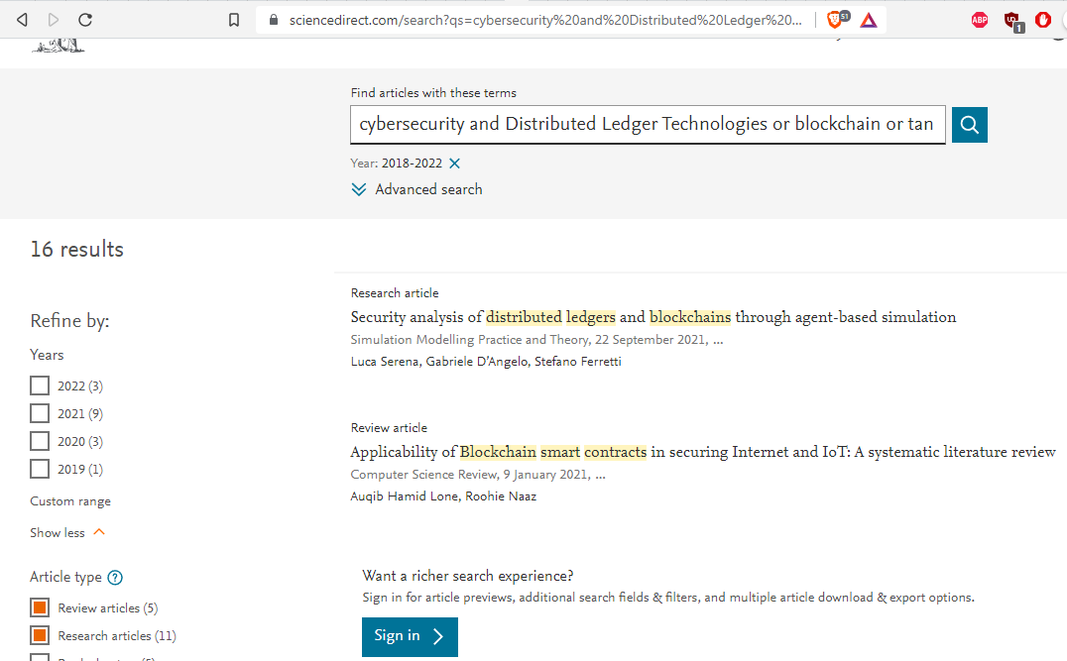

**Redalyc**

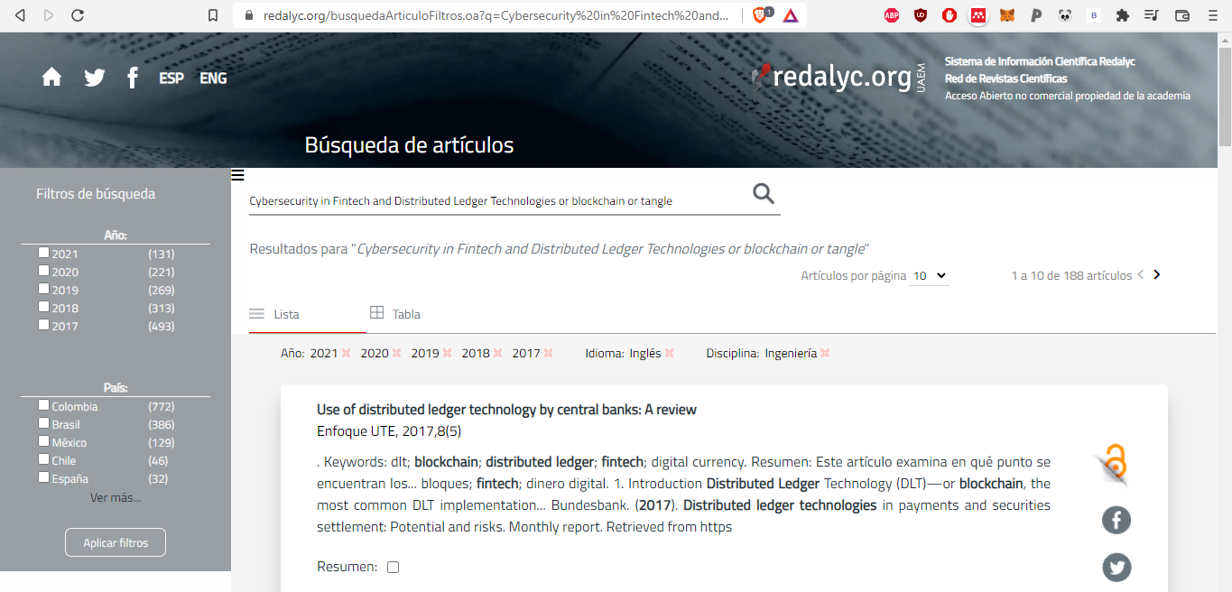

**Taylor and Francis**

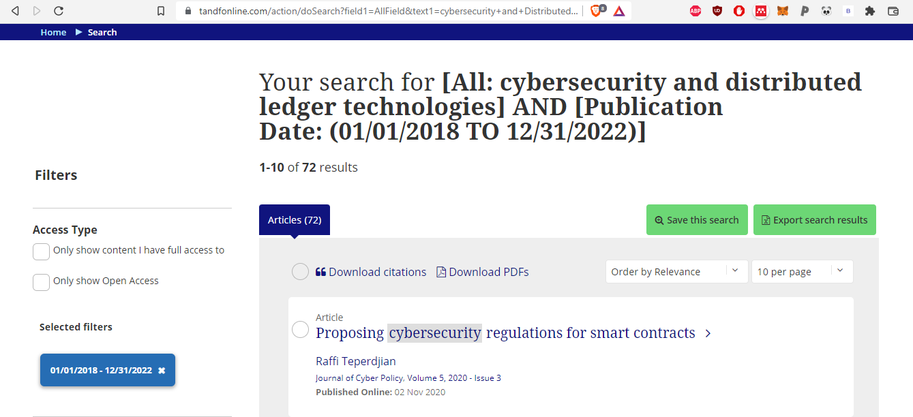

**Fases de Revisión**

|  |  |
| --- | --- |
| **Bases de datos** | **Total de artículos encontrados** |
| IEEE Xplorer | 354 |
| Science Direct | 16 |
| Redalyc | 188 |
| Taylor and Francis | 72 |
| **Total** | 630 |

**Presentación de Resultados.**

|  |  |  |  |  |  |  |  |
| --- | --- | --- | --- | --- | --- | --- | --- |
| No. | Título | Ref. | Base de datos | Tipo de artículo | SJR Cuartil | Año | País |
| 1 | A $10 million question and other cybersecurity-related ethical dilemmas amid the COVID-19 pandemic | [3] | Science Direct | Jorunal | Q1 | 2021 | United Kingdom |
| 2 | División financiera del trabajo en sistemas de pagos en Argentina y Brasil | [1] | Redalyc | Journal | Q4 | 2019 | Venezuela |
| 3 | Distributed Ledger Technology (DLT): The Beginning of a Technological Revolution for Blockchain | [5] | IEEE | Conferences paper | Q1 | 2020 | United States |
| 4 | Examining factors that boost intention and loyalty to use Fintech post-COVID-19 lockdown as a new normal behavior | [8] | Science Direct | Journal | Q1 | 2021 | Netherlands |
| 5 | The effect of COVID-19 on long memory in returns and volatility of cryptocurrency and stock markets | [9] | Science Direct | Journal | Q1 | 2021 | United Kingdom |
| 6 | Did COVID-19 change spillover patterns between Fintech and other asset classes? | [10] | Science Direct | Journal | Q2 | 2021 | Netherlands |
| 7 | Cybercrime in a time of coronavirus | [11] | Science Direct | Journal | Q2 | 2020 | United Kingdom |
| 8 | Cybersecurity Vulnerabilities in FinTech | [12] | Springer | Book | ------- | 2021 | Switzerland |
| 9 | Cybersecurity Threats in FinTech | [13] | Springer | Book | ------- | 2021 | Switzerland |
| 10 | Managing IoT devices using blockchain platform | [14] | IEEE | Conferences paper | Q2 | 2017 | United States |
| 11 | Investing during a Fintech Revolution: Ambiguity and return risk in cryptocurrencies, | [15] | Science Direct | Journal | Q1 | 2021 | Netherlands |
| 12 | Smart contracts vulnerabilities: a call for blockchain software engineering? | [16] | IEEE | Conferences paper | Q1 | 2018 | United States |
| 13 | Blockchain-enabled fraud discovery through abnormal smart contract detection on Ethereum | [17] | Science Direct | Journal | Q1 | 2021 | Netherlands |
| 14 | To Blockchain or Not to Blockchain: That Is the Question | [19] | IEEE | Journal | Q2 | 2018 | United States |
| 15 | Affordances, experimentation and actualization of FinTech: A blockchain implementation study | [20] | Science Direct | Journal | Q1 | 2019 | Netherlands |
| 16 | Problems of Using Redactable Blockchain Technology | [21] | Science Direct | Journal | Q2 | 2021 | Netherlands |
| 17 | The market for bitcoin transactions | [22] | Science Direct | Journal | Q1 | 2021 | Journal of International Financial Markets |
| 18 | Renewable Energy Will Not Solve Bitcoin’s Sustainability Problem | [25] | Science Direct | Journal | Q1 | 2019 | United States |
| 19 | The impact of the shutdown policy on the asymmetric interdependence structure and risk transmission of cryptocurrency and China’s financial market | [26] | Science Direct | Journal | Q2 | 2021 | United States |
| 20 | A survey on applications and security issues of blockchain technology in business sectors | [27] | Science Direct | Journal | Q2 | 2021 | United Kingdom |
| 21 | Securing Logs of a System - An IoTA Tangle Use Case | [28] | IEEE | Conferences paper | Q2 | 2020 | United States |
| 22 | Blockchain and the built environment: Potentials and limitations | [30] | Science Direct | Journal | Q1 | 2019 | Netherlands |
| 23 | Blockchain technology: Business, strategy, the environment and sustainability | [31] | Science Direct | Journal | Q1 | 2019 | United Kingdom |
| 24 | Evaluation of Performance and Security of Proof of Work and Proof of Stake using Blockchain | [32] | IEEE | Conferences paper | Q1 | 2021 | India |
| 25 | Evaluation of Proof of Work (POW) Blockchains Security Network on Selfish Mining | [33] | IEEE | Conferences paper | Q2 | 2018 | United States |
| 26 | Proof of Contribution: A Modification of Proof of Work to Increase Mining Efficiency | [34] | IEEE | Conferences paper | Q1 | 2018 | United States |
| 27 | Analysis of information security in the PoW (Proof of Work) and PoS (Proof of Stake)blockchain protocols as an alternative for handling confidential nformation in the public finance ecuadorian sector | [35] | IEEE | Conferences paper | Q1 | 2021 | United States |
| 28 | An Analysis of Routing Attacks Against IOTA Cryptocurrency | [36] | IEEE | Conferences paper | Q2 | 2020 | United States |
| 29 | A Blockchain Solution based on Directed Acyclic Graph for IoT Data Security using IoTA Tangle | [37] | IEEE | Conferences paper | Q1 | 2020 | United States |
| 30 | Iota Tangle: A cryptocurrency to communicate Internet-of-Things data | [38] | Science Direct | Journal | Q1 | 2020 | Netherlands |
| 31 | Characterizing IOTA Tangle with Empirical Data | [39] | IEEE | Conferences paper | Q1 | 2020 | United States |
| 32 | Iota vs. Ripple: A Comparison Inside An Economy of Things Architecture for Industry 4.0 | [40] | IEEE | Conferences paper | Q1 | 2020 | United States |
| 33 | A systematic literature review of blockchain cyber security | [42] | Science Direct | Journal | Q1 | 2020 | China |
| 34 | The state of play of blockchain technology in the financial services sector: A systematic literature review | [43] | Science Direct | Journal | Q1 | 2020 | United Kingdom |
| 35 | Blockchain technology in the future of business cyber security and accounting | [44] | Taylor and Francis | Journal | Q1 | 2020 | United Kingdom |
| 36 | An Overview of the Artificial Intelligence Applications in Fintech and Regtech | [51] | Springer | Book | ------ | 2021 | Shingapore |
| 37 | Emergence of Fintech and cybersecurity in a global financial centre: Strategic approach by a regulator | [52] | Taylor and Francis | Journal | Q3 | 2017 | United Kingdom |
| 38 | Bitcoin Concepts, Threats, and Machine-Learning Security Solutions | [56] | IEEE | Journal | Q1 | 2018 | United States |
| 39 | Fintech and Sustainability: Do They Affect Each Other? | [57] | Science Direct | Journal | Q2 | 2021 | Switzerland |
| 40 | A systematic review of blockchain | [58] | Springer | Journal | Q2 | 2019 | Germany |
| 41 | Ethereum smart contracts: Analysis and statistics of their source code and opcodes | [60] | Science Direct | Journal | Q1 | 2020 | United States |
| 42 | A security framework for Ethereum smart contracts | [61] | Science Direct | Journal | Q1 | 2021 | Netherlands |
| 43 | Performance evaluation of permissioned blockchains for financial applications: The ConsenSys Quorum case study | [63] | Science Direct | Journal | Q1 | 2021 | United States |
| 44 | A survey of breakthrough in blockchain technology: Adoptions, applications, challenges and future research | [64] | Science Direct | Journal | Q1 | 2021 | Netherlands |
| 45 | Permissioned blockchain frameworks in the industry: A comparison | [65] | Science Direct | Journal | Q1 | 2021 | South Korea |
| 46 | Blockchain technology - Is it hype or real in the construction industry | [67] | Science Direct | Journal | Q1 | 2020 | Netherlands |
| 47 | Banking with blockchain-ed big data | [68] | Taylor and Francis | Journal | Q2 | 2018 | United Kingdom |
| 48 | Recent advances in consensus protocols for blockchain: a survey | [69] | Springer | Journal | Q2 | 2020 | Netherlands |
| 49 | Blockchain 3.0 applications survey | [71] | Science Direct | Journal | Q1 | 2020 | United States |
| 50 | Privacy aware IOTA ledger: Decentralized mixing and unlinkable IOTA transactions, | [73] | Science Direct | Journal | Q1 | 2019 | Netherlands |
| 51 | Applicability and Appropriateness of Distributed Ledgers Consensus Protocols in Public and Private Sectors | [74] | IEEE | Journal | Q1 | 2019 | United States |
| 52 | A survey on consensus methods in blockchain for resource-constrained IoT networks | [75] | Science Direct | Journal | Q1 | 2020 | United States |
| 53 | Unification of Blockchain and Internet of Things (BIoT): requirements, working model, challenges and future directions | [76] | Springer | Journal | Q2 | 2021 | Netherlands |
| 54 | Blockchain for IoT-based smart cities: Recent advances, requirements, and future challenges | [77] | Science Direct | Journal | Q1 | 2021 | United States |
| 55 | Ethereum smart contract security research: survey and future research opportunities | [78] | Springer | Journal | Q2 | 2021 | United States |
| 56 | FinTech payments in the era of COVID-19: Factors influencing behavioral intentions of “Generation X | [79] | Science Direct | Journal | Q2 | 2021 | Netherlands |
| 57 | Cybersecurity Attacks During COVID-19: An Analysis of the Behavior of the Human Factors and a Proposal of Hardening Strategies | [83] | Springer | Journal | Q1 | 2021 | United States |
| 58 | A Multivocal Literature Review on Growing Social Engineering Based Cyber-Attacks/Threats During the COVID-19 Pandemic: Challenges and Prospective Solutions | [84] | IEEE | Journal | Q1 |  | United States |
| 60 | Blockchain adoption: A value driver perspective | [85] | Science Direct | Journal | Q1 | 2019 | United Kingdom |
| 61 | Survey on IoT security: Challenges and solution using machine learning, artificial intelligence and blockchain technology | [86] | Science Direct | Journal | Q1 | 2020 | United States |
| 61 | Blockchain for Industry 4.0: A Comprehensive Review | [87] | IEEE | Journal | Q1 | 2020 | United States |
| 63 | 20 years of research in microfinance: An information management approach | [88] | Science Direct | Journal | Q1 | 2019 | United Kingdom |
| 64 | Agile development in the cloud computing environment: A systematic review | [90] | Science Direct | Journal | Q2 | 2018 | Netherlands |
| 65 | Blockchain-based identity management systems: A review | [91] | Science Direct | Journal | Q1 | 2020 | United States |
| 66 | Construction quality information management with blockchains | [92] | Science Direct | Journal | Q1 | 2020 | Netherlands |
| 67 | Distributed ledger technology: Its evolutionary path and the road ahead | [93] | Science Direct | Journal | Q1 | 2021 | Netherlands |
| 68 | Distributed ledger technology as a catalyst for open innovation adoption among small and medium-sized enterprises | [94] | Science Direct | Journal | Q2 | 2021 | United Kingdom |
| 69 | Blockchain for Cybersecurity in Smart Grid: A Comprehensive Survey | [95] | IEEE | Journal | Q1 | 2021 | United States |
| 70 | A critical review on using blockchain technology in education domain, | [96] | Springer | Book | ----- | 2021 | Singapore |
| 71 | The convergence of IoT and distributed ledger technologies (DLT): Opportunities, challenges, and solutions | [97] | Science Direct | Journal | Q1 | 2021 | United States |
| 72 | A systematic review of blockchain scalability: Issues, solutions, analysis and future research, | [98] | Science Direct | Journal | Q1 | 2021 | United States |
| 73 | A survey of Blockchain consensus algorithms: mechanism, design and applications | [99] | Springer | Journal | Q1 | 2020 | China |
| 74 | Security and blockchain convergence with Internet of Multimedia Things: Current trends, research challenges and future directions | [100] | Science Direct | Journal | Q1 | 2021 | United States |
| 75 | The blockchain: State-of-the-art and research challenges | [101] | Science Direct | Journal | Q1 | 2019 | Netherlands |
| 76 | A survey on privacy protection in blockchain system | [102] | Science Direct | Journal | Q1 | 2019 | United States |
| 77 | Blockchain for Internet of Things: A Survey | [103] | IEEE | Journal | Q1 | 2019 | United States |
| 78 | Blockchain Security by Design Framework for Trust and Adoption in IoT Environment | [104] | IEEE | Conferences Journal | Q1 | 2019 | United States |
| 79 | Public and private blockchain in construction business process and information integration | [105] | Science Direct | Journal | Q1 | 2020 | Netherlands |
| 80 | Integration of Blockchain and Cloud of Things: Architecture, Applications and Challenges | [107] | IEEE | Journal | Q1 | 2020 | United States |
| 81 | Analysis of smart contracts balances | [110] | Science Direct | Journal | Q1 | 2021 | Netherlands |
| 82 | Tokenization of sukuk: Ethereum case study | [111] | Science Direct | Journal | Q2 | 2022 | Netherlands |
| 83 | A Comprehensive Survey on Attacks, Security Issues and Blockchain Solutions for IoT and IIoT | [117] | Science Direct | Journal | Q1 | 2020 | United States |
| 84 | IOTA: Feeless and Free, | [118] | IEEE | Journal | Q1 | 2019 | United States |
| 85 | Issues and Trends in Information Security Policy Compliance | [124] | IEEE | Conferences Journal | Q1 | 2019 | United States |
| 86 | Information Security in the Management of Personnel in a Modern Organization | [125] | IEEE | Conferences Journal | Q1 | 2020 | United States |
| 87 | Problems of Implementing Information Security Management Systems | [126] | IEEE | Conferences Journal | Q1 | 2020 | United States |
| 88 | Information Security Protection in Software Testing | [127] | IEEE | Conferences Journal | Q1 | 2018 | United States |
| 89 | A survey on cybersecurity awareness concerns, practices and conceptual measures | [129] | IEEE | Conferences Journal | Q1 | 2019 | United States |
| 90 | Internet of Things (IoT) Cybersecurity Research: A Review of Current Research Topics | [130] | IEEE | Journal | Q1 | 2019 | United States |
| 91 | Cyber Security Threats and Vulnerabilities: A Systematic Mapping Study | [132] | Springer | Journal | Q2 | 2020 | Germany |
| 92 | On cloud security requirements, threats, vulnerabilities and countermeasures: A survey | [134] | Science Direct | Journal | Q1 | 2019 | Ireland |
| 93 | Data Security and Privacy Protection for Cloud Storage: A Survey | [135] | IEEE | Journal | Q1 | 2020 | United States |
| 94 | Forty years of attacks on the RSA cryptosystem: A brief survey | [136] | Taylor and Francis | Journal | Q3 | 2019 | United Kingdom |
| 95 | Development of modified AES algorithm for data security | [137] | Science Direct | Journal | Q2 | 2016 | Germany |
| 96 | Microservices: The Evolution and Extinction of Web Services | [142] | Springer | Book | ------- | 2019 | Italy |
| 97 | Information security maturity model: A best practice driven approach to PCI DSS compliance | [146] | IEEE | Conferences Journal | Q1 | 2016 | United States |

# Bibliografía

|  |  |
| --- | --- |
| [1] | B. E., «An Overview of Google Cloud Platform Services,» *Building Machine Learning and Deep Learning Models on Google Cloud Platform,* 2019. |
| [2] | K. Gupta, «SLoBLING: Systematic Literature Review of BlockChain, IoT and Google Cloud Platform,» *Mukt Shabd Journal,* vol. IX, nº VIII, pp. 441-443, 2020. |
| [3] | P. L. M. S. Muhammad Waseem, «A Systematic Mapping Study on Microservices Architecture in DevOps,» *Journal of Systems and Software,* vol. 170, 2020. |
| [4] | H. Z. Z. J. C. Z. C. Z. Z. S. J. S. M. A. B. Shanshan Li, «Understanding and addressing quality attributes of microservices architecture: A Systematic literature review,» *Information and Software Technology,* vol. 131, 2021. |
| [5] | A. D. Pham, «Developing back-end of a web application with NestJS framework: Case: Integrify Oy’s student management system,» 2020. |
| [6] | G. M. Baresi L., «Microservices: The Evolution and Extinction of Web Services?,» *Bucchiarone A. et al. (eds) Microservices,* 2020. |
| [7] | S. Popov, «IOTA: Feeless and Free,» *IEEE Blockchain Technical Briefs,* 2019. |
| [8] | A. Panarello, N. Tapas, G. Merlino, F. Longo y A. Puliafito, «Blockchain and IoT Integration: A Systematic Survey,» *Sensors,* vol. 18, nº 8, 2018. |
| [9] | X. Fan y Q. Chai, «Roll-DPoS: A Randomized Delegated Proof of Stake Scheme for Scalable Blockchain-Based Internet of Things Systems,» *In Proceedings of the 15th EAI International Conference on Mobile and Ubiquitous Systems: Computing, Networking and Services,* 2018. |
| [10] | A. Pieroni, N. Scarpato y L. Felli, «Blockchain and IoT Convergence—A Systematic Survey on Technologies, Protocols and Security,» *Applied Sciences,* vol. 10, nº 19, 2020. |
| [11] | M. A. Jan, J. Cai, X.-C. Gao, F. Khan, S. Mastorakis, M. Usman, M. Alazab y P. Watters, «Security and blockchain convergence with Internet of Multimedia Things: Current trends, research challenges and future directions,» *Journal of Network and Computer Applications,* vol. 175, 2021. |
| [12] | N. Khan, B. Kchouri, N. A. Yatoo, Z. Kräussl, A. Patel y R. State, «Tokenization of sukuk: Ethereum case study,» *Global Finance Journal,* 2020. |
| [13] | Tatum, «Welcome to Tatum,» 2022. [En línea]. Available: https://docs.tatum.io/. [Último acceso: 19 01 2022]. |
| [14] | Tatum, «Arquitectura de Tatum,» 2022. [En línea]. Available: https://docs.tatum.io/tatum-architecture. [Último acceso: 19 01 2022]. |
| [15] | I. Team, «Introducing IOTA Stronghold,» 19 07 2020. [En línea]. Available: https://blog.iota.org/iota-stronghold-6ce55d311d7c/. [Último acceso: 20 01 2022]. |
| [16] | U. I. D. TELECOMUNICACIONES, «Arquitectura de seguridad para sistemas de comunicaciones extremo a extremo,» *UIT-T,* 2003. |
| [17] | A. O. Richard, «Security assessments of IEEE 802.15.4 standard based on X.805 framework,» *Int. J. Security and Networks,* vol. 5, p. 5, 2010. |
| [18] | M. Majid y P. Luo, «Forty years of attacks on the RSA cryptosystem: A brief survey,» *Journal of Discrete Mathematical Sciences and Cryptography,* pp. 9-29, 2019. |